Getting the Most Out of Math Jewels

How can we balance open-ended discovery, in-depth exploration, and accountability?

- Asking Useful Questions

  - For each site, develop two or three questions that are probing and open-ended, providing
some direction and some flexibility.
    - Questions may be asked as students arrive at the site, during their visit, or
at the end of their visit.
    - Responses may be written, discussed in small groups, or discussed as a class.

  - Webquests – create a page asking students to:
    - collect or analyze specific information
    - try one or more specific or open-ended tasks and/or
    - develop a computer project to apply or synthesize some aspect of the site visit.

- Organizing the Classroom for productive computer activities

  - With one computer and a projector or large monitor:

    - a whole class can explore web activities cooperatively or competitively.
(Give individuals or small groups a chance to record and share predictions.)

    - a teacher can demonstrate how students will explore independently.

  - With five or more desktop or laptop computers, the whole class can explore computer activities in small groups at the same time.

  - With two or three computers, and two or three students sharing each computer, a whole
class can rotate through a computer learning center during two or three class periods.

Enlist student helpers to demonstrate activities and assist as needed.

- Assessing Understanding

  - teacher's informal observations and notes during computer activities and discussions

  - students’ responses to questions - written and oral

  - assessment rubrics –
see Kathy Schrock's Assessment and Rubric Information
http://school.discovery.com/schrockguide/assess.html

  - teach a friend

  - learning journal: reporting, reflecting, connecting

  - printouts of screenshots with captions for a portfolio

  - digital portfolio

  - improvement on some standard measures

  - extension activities
Sample Questions

What a Crowd! (an estimation activity)  www.mathcats.com/microworlds/whatacrowd.html  What strategies did you use to make your estimates?  Did you find it easier to estimate crowds of a certain size range? If so, what range? Why do you think it was easier to estimate crowds of this size? | 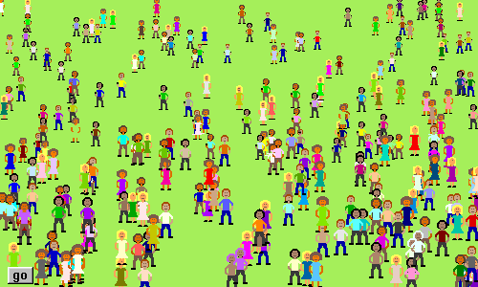

Math Cats Balance  www.mathcats.com/explore/balance/balance.html  Can you get two different objects to balance on the Math Cats Balance? (If not, get as close as you can.) Write an equation comparing the two objects.  Ex: 4000 Jupiters = 1 sun OR  balancing Jupiter, sun: 4000 J = 1 S  1 house > 20 dinosaurs OR  balancing house, dinosaurs: 1 H > 20 D | 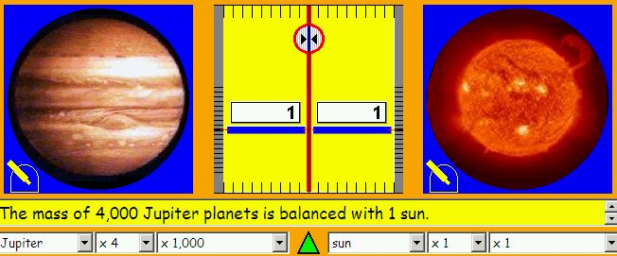  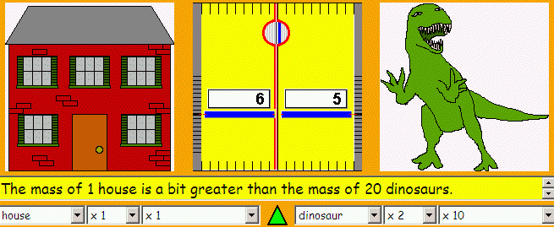

Exactly... how old are you??? (age calculator)  www.mathcats.com/explore/age/calculator.html  How many weeks old are you? How many days?  We know there are 7 days in each week. Multiply your age in weeks by 7. Does it match exactly with your age in days? (If not, why is there a slight difference?)  How many hours are there in a day?  Multiply your age in days by that number; does it match your age in hours? (If not, can you explain the difference?)  Do some ways of reporting your age make you feel older? If so, do you feel oldest in years, months, weeks, days, hours, minutes, or seconds? Why? | 